**Deep learning ICP 6**

**Task1: By using fashion_MNIST_data**

**Case 1** : we are using **Gradient decent optimizer** with the filter sizes 16, 36 and final layer 128.

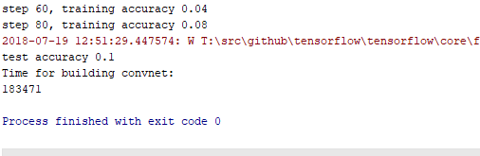

**Observation** : we are getting less accuracy of about 0.1 in this case.

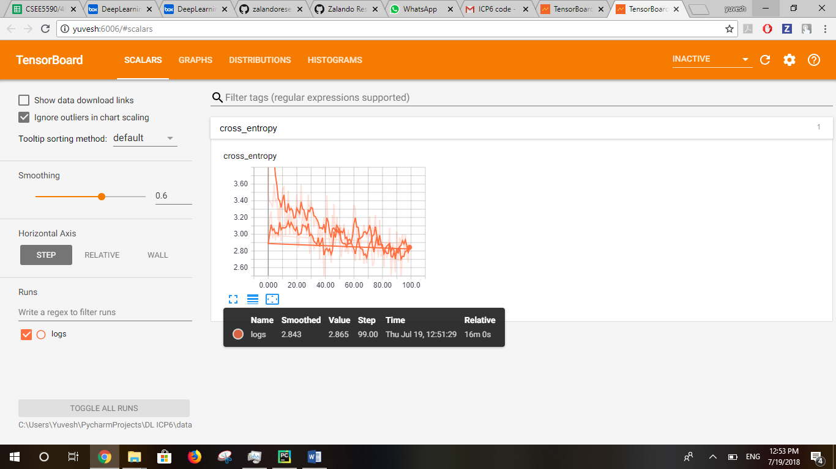

**Case 2** : we are using **AdamOptimizer** with the default filter sizes 32, 64 and final layer 1024.

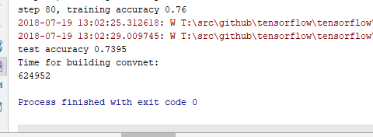

**Observation** : In this case, by using the default filter size 32, 64 and final layer 1024, we are getting **more accuracy** compared to the case 1.

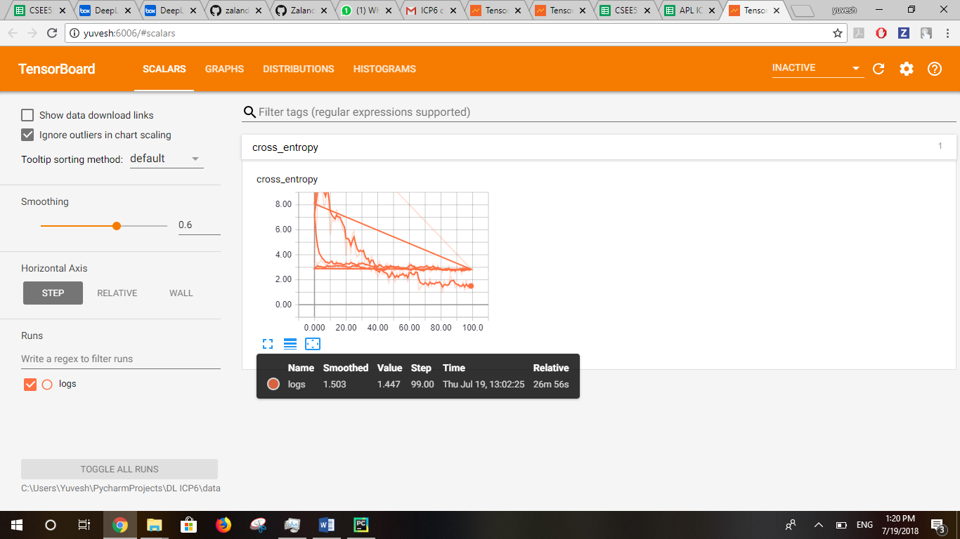

**Task 2 : By using MNIST_data**

**Case 1** : In this case I am using the **AdamOptimizer** with the default filter size 32, 64 and final layer 1024 in order to find the best optimizer which provides good accuracy.

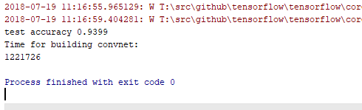

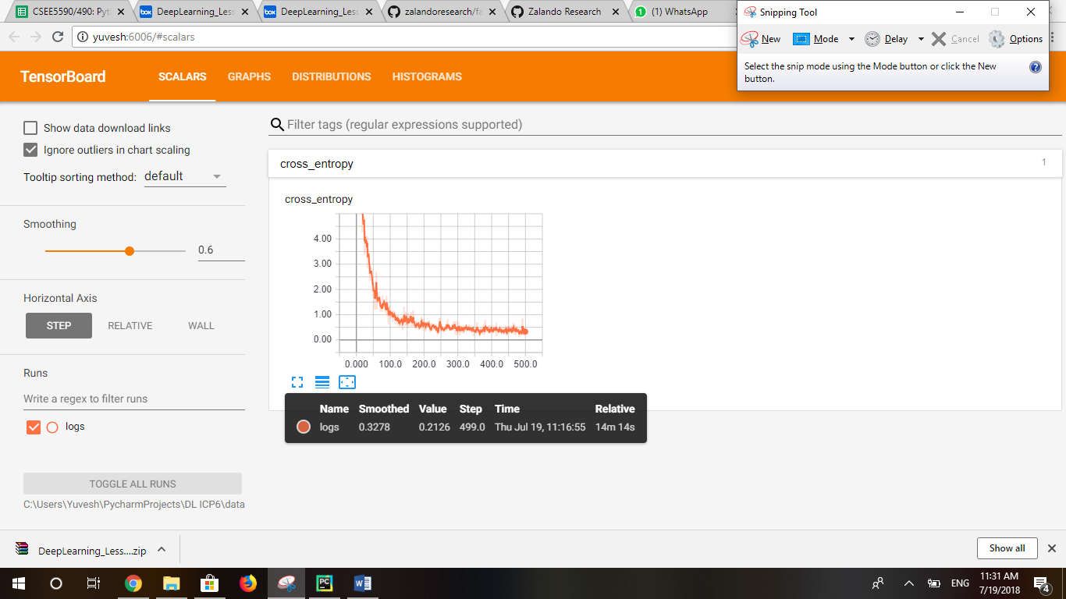

**Case 2** : In this case I am using the **AdaGradOptimizer** with the default filter size 32, 64 and final layer 1024 in order to find the best optimizer which provides good accuracy.

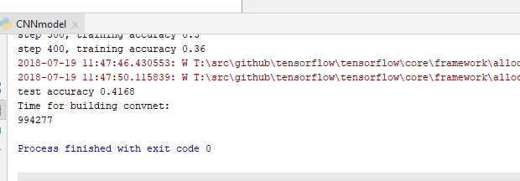

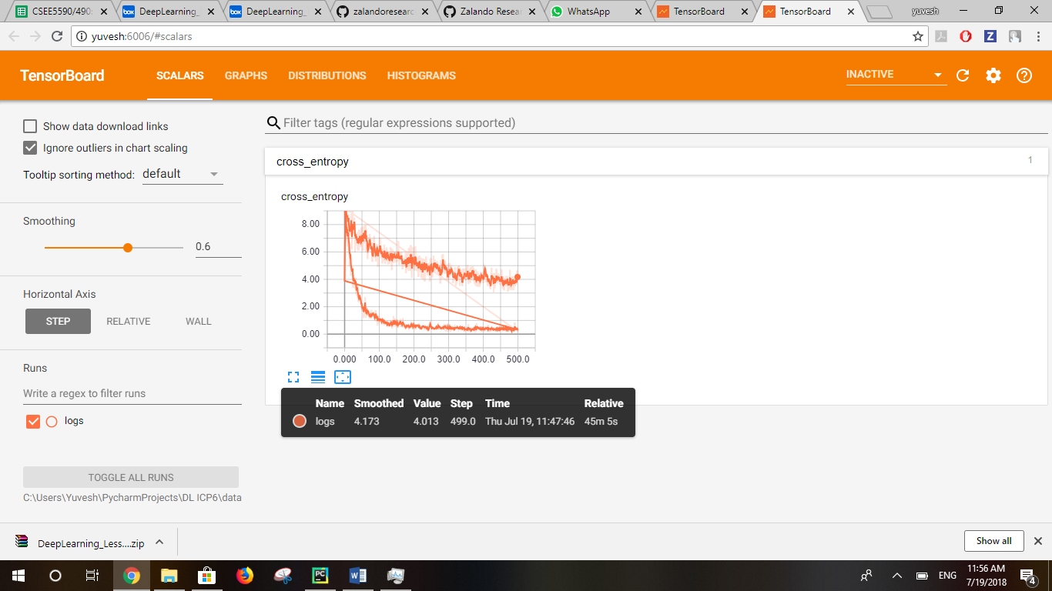

**Case 3** : In this case I am using the **GradientDescentOptimizer** with the default filter size 32, 64 and final layer 1024 in order to find the best optimizer which provides good accuracy.

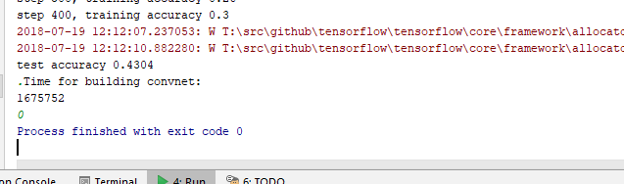

**Observation** : Of all the above three optimizers, we are getting good accuracy for the

**AdamOptimizer.**

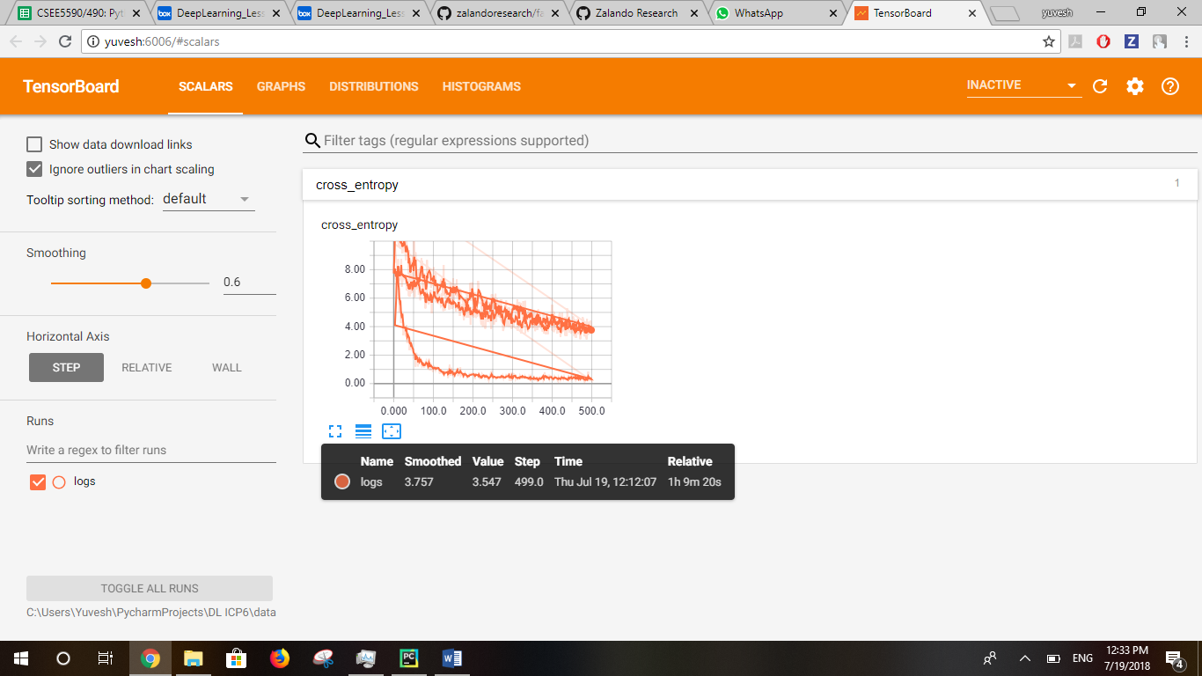

This is the output graph plotted in the tensorboard.

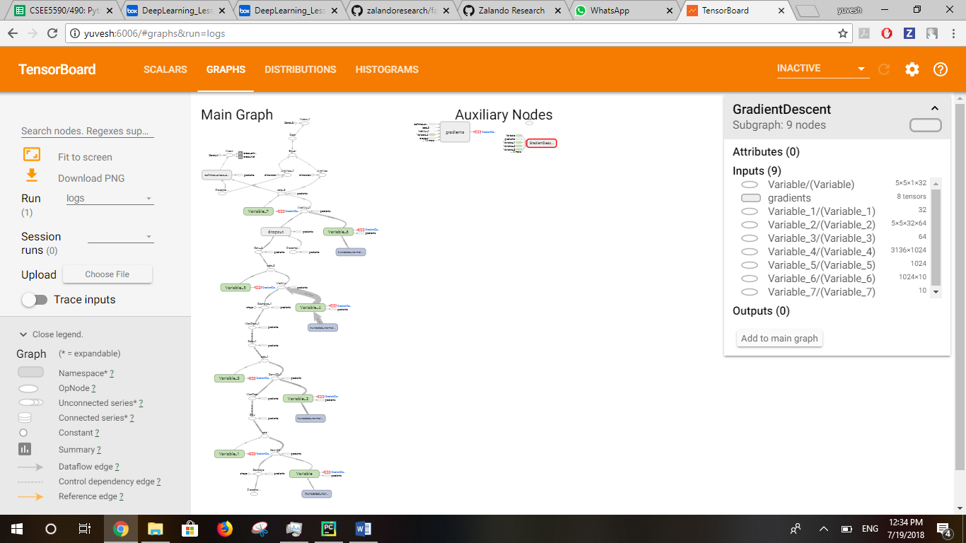

**Case 4** : In this case I am using the **GradientDescentOptimizer** with the different filter size 16, 36 and final layer 128.

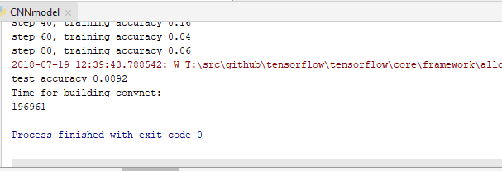

The output Graph in the tensorboard.

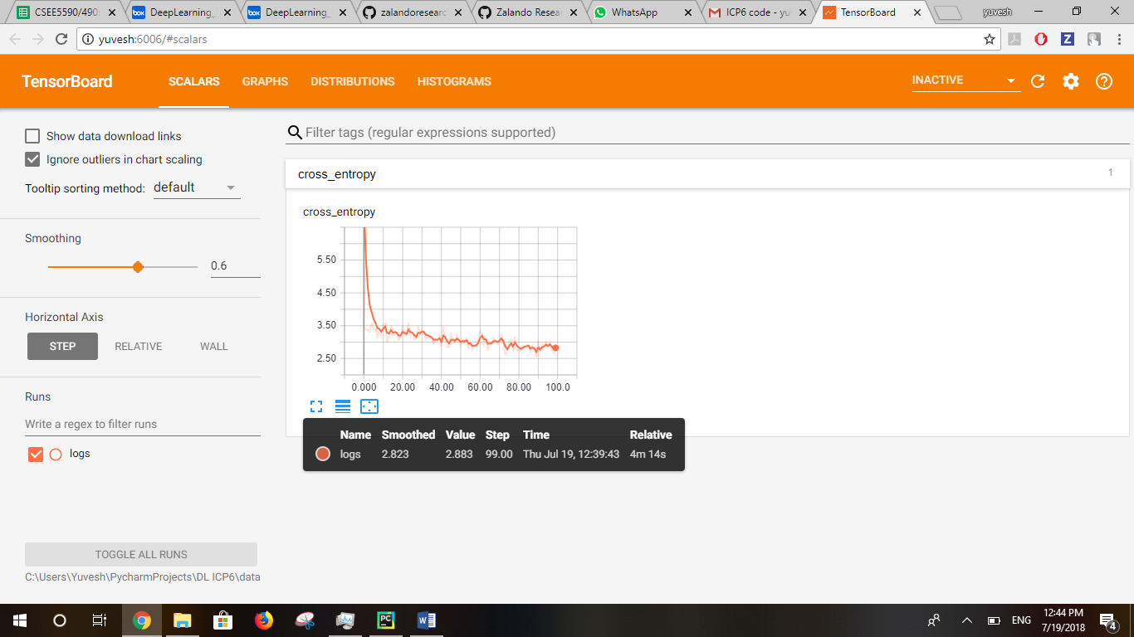

**Observation** : In this case when the filter size and the final layer is changed, the accuracy is **decreased** from 0.4304 to 0.0892 by using the **GradientDescentOptimizer.** So the accuracy is more by using the default filter size 32, 64 and final layer 1024 compared to the case 4.